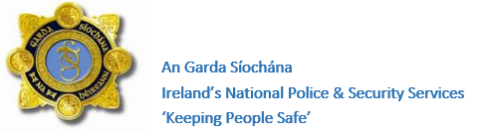
Please attached a recent photo here.
Please find one that is up to date and a good likeness of the person.
If possible, consider using a digital photo when providing the Herbert Protocol Questionnaire to An Garda Síochána


HERBERT PROTOCOL QUESTIONNAIRE

IMPORTANT: Please read the Herbert Protocol Questionnaire guidance document when filling out this questionnaire
PERSONAL CONTACT DETAILS
1. Name
2. Does the person have any nicknames?
3. Do they know/ respond to their own name? | Yes No
4. Address
Include eircode
5. Date of Birth | DD/MM/YYYY
6. Nationality
7. What languages does the person speak?
8. Mobile number
Mobile provider
9. Does the person carry a GPS tracker .i.e. a GPS watch or phone?  If yes, Please provide details | Yes No

PHYSICAL APPEARANCE DETAILS
10. Gender
11. Weight/ Build

12. Height

13. Eye colour  Do they wear glasses | Yes No
14. Hair Colour

15. Skin colour / complexion

16. Distinctive Physical Features
MEDICAL DETAILS
17. Does the person have any other medical conditions or require medications.
18. Access to Message in a Bottle? | Yes No  If yes, please attach a copy of the MIAB to the back of the Herbert Protocol Questionnaire with all medical information
If No, please provide the following | Vital Medications:  Frequency required:  Symptoms if missed:
19. Symptom the person is displaying | Memory loss  Confusion  Language difficulties  Failure to recognise people or objects  Hallucinations and delusions  Mood swings  Impaired reasoning and judgement  Other, please state:
20. How does dementia affect this person?

TRAVEL AND ASSOCIATED LOCATIONS
21. Does the person have access to a vehicle? | Yes No  If yes provide details:
22. Do they travel independently? Or have a free travel pass/ leap card etc. | Yes No  If yes provide details:
23. Favourite places they like to visit

24. Does the person require a walking or mobility aid? | Yes No
25. How might they react to strangers approaching them?
26. Has the person gone missing before?

27. Provide previous home addresses

28. Provide address of previous workplaces of the person.
29. Additional information

Next Of Kin Details

Name
Address
Date of Birth
Relationship to person
Contact Details

Details of Person who completed the Herbert Protocol Questionnaire / Point of contact details

Name

Address

Date of birth

Contact details
Date last Herbert Protocol Questionnaire updated

