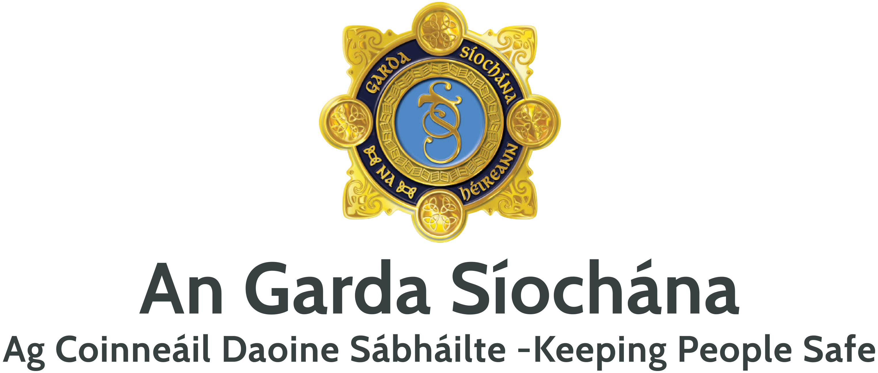

14 August 2025

**Report by Crowe consultants into roads policing**

Colleagues,

This morning, the report by Crowe consultants into roads policing will be published. It makes for stark reading.

After speaking with over 100 Gardaí in Roads Policing Units in six Divisions, Crowe’s findings are shocking and disturbing, particularly given the importance of this work in saving lives and preventing life-altering injuries.

While they found the majority of Roads Policing Gardaí were professional, dedicated and productive, they also met a significant cohort of officers who are disinterested, have a poor work ethic and deliberately ignored offences.

This is very disappointing, as is the fact that some Roads Policing Gardaí had no issue with openly outlining to the researcher how they go about avoiding work and their lack of interest in roads policing.

It is also unsatisfactory that their supervisors do not believe they can or should engage in performance management with these individual Gardaí.

The report identifies resourcing as an issue. In the last year, we have allocated an additional 49 Gardaí to roads policing and more will be allocated in the second half of the year.

The report also outlines issues with training, equipment, fleet and structures.

Measures taken to date to enhance roads policing include €1m invested in roads policing equipment in the last 18 months, €5m in new fleet since 2022 with 16 more vehicles to come shortly, implementation of phase one of a national safety camera network, and the 30-minute road policing initiative. But it is clear from the report that collectively we need to do more.

As recommended by the report, a Steering Group under Deputy Commissioner, Policing Operations has been established, and a Working Group under Assistant Commissioner, Roads Policing and Community Engagement to implement the findings.

This will result in further improvements in roads policing.

But, they will only be of benefit if the vital work to police our roads is carried out by Gardaí in a professional and effective manner.

I am confident that across road policing and our regular units that this is the case for the majority of Gardaí.

However, there now needs to be a collective effort to deal with under-performance in roads policing.

We must always remember the families of those killed and those seriously injured in road traffic collisions. Opportunities for enforcement in respect of very poor driving have been lost. We cannot know the impact of this but this must not be the practice of some Gardaí into the future.

Any member of An Garda Síochána – either Garda or supervisor - failing to perform their duties is a breach of trust with the public who depend on us to keep them safe.

We must now all work collectively to re-build that trust and continue the great work done by the majority of Gardaí every day to save lives and prevent injuries.

**Commissioner Drew Harris**

You can read the Crowe report [**here**](https://www.garda.ie/en/about-us/publications/general-reports/independent-review-of-roads-policing-crowe-report-/).