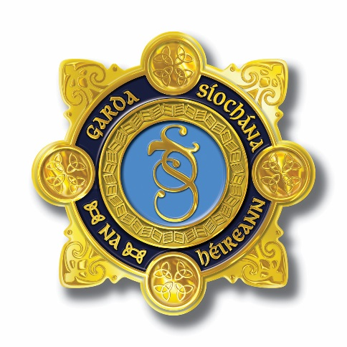

An Garda Síochána

Monthly Report for February 2026 to the Policing and Community Safety Authority

In accordance with Section 133 (1) of the Policing, Security and Community Safety Act, 2024

An Garda Síochána

Oifig an Choimisinéara  An Garda Síochána  Páirc an Fhionnuisce  Baile Átha Cliath 8  D08 HN3X  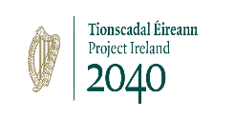  Luaigh an uimhir tharaghta seo a leanas le do thoil:  Please quote the following ref. number: CMR_86-49721/26 | 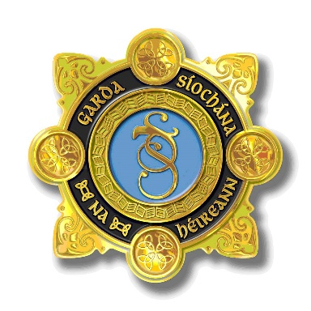 | Office of the Commissioner  Garda Headquarters  Phoenix Park  Dublin 8  D08 HN3X  Láithreán Gréasáin/ Website:  www.garda.ie  Ríomhpost/E-mail:  commissioner@garda.ie

Ms. Helen Hall
Chief Executive
Policing and Community Safety Authority

RE: Commissioner’s Monthly Report to the Policing and Community Safety Authority
______________________________________________________________________________

Dear Helen,

I am pleased to provide the Commissioner’s Monthly Report, outlining the key aspects of the administration and operation of An Garda Síochána for the month of February 2026, in accordance with Section 133(1) of the Policing, Security and Community Safety Act, 2024.

Yours sincerely,

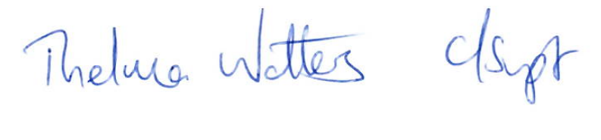
THELMA WATTERS
CHIEF SUPERINTENDENT
COMMISSIONER’S OFFICE

20th March 2026

1. Message from the Commissioner

During the month of February 2026, I was delighted to welcome 167 Gardaí into An Garda Síochána, following an attestation ceremony held in the Garda College on 6 February 2026.

These Gardaí were recruited as part of the 2024/25 recruitment campaigns and have gone on to take up positions in each of the four regions across the country. A further 215 Garda Trainees, began their training on 9 February 2026, the largest cohort in a significant period of time. The newly attested Gardaí have led to further growth in the organisation, with our Garda strength now standing at 14,529, supported by a Garda Staff strength of 3,679.

A significant milestone was reached in Co. Cork where a contractor took charge of the site in Macroom, which will be developed as the new Cork County Divisional Headquarters. I was pleased to attend a sod turning event with the Minister for Justice, Home Affairs and Migration, Jim O’Callaghan TD and the Minister of State with responsibility for the Office of Public Works, Kevin ‘Boxer’ Moran on 20 February 2026. This marked the commencement of works on this significant project for the Southern Region.

Also on that date, I was delighted to attend and present awards at the 30th Coiste Siamsa Awards event, held in Thomond Park Stadium in Limerick City. The Coiste Siamsa awards provide an important opportunity each year to acknowledge the dedication, discipline and commitment required to compete at a high level across many sports disciplines, while also serving in a demanding profession. This also reflects our continued work to support our members’ wellbeing and supporting active participation in sports.

We remain committed to upskilling and professionalising our management team to meet the dynamic needs and governance demands anticipated from An Garda Síochána. I was delighted to formally sign a contract for the Garda Executive Leadership Programme, following a comprehensive tender process, with Trinity College Dublin on 5 February 2026. This will deliver expert-led training to strengthen strategic capability and enhance public trust.

I met with the AGSI National Executive at their offices, where we discussed concerns and opportunities that are important to their members at both Sergeant and Inspector rank. I undertook to engage with my Executive Leadership Team to consider early solutions which are within my capacity. I look forward to further constructive engagement with AGSI and their conference in March 2026.

As we continue with policing and security preparation for the EU Presidency, we continue to manage the many day to day challenges across the country focussed on keeping our people safe.

The 10th anniversary of the organised crime assault and murder at the Regency Hotel in Dublin in 2016 was marked with a briefing to highlight key developments in the area of organised and serious crime over that period of time. There have been many challenges in that period of time and the significant proactive and persistent policing of organised crime groups with international partners, and at home on a national and divisional level, have led to significant detections and prosecutions through our criminal justice system.

The consistent policing impact in this area has led to a significant reduction in serious crime and notably through 2025, there have been no organised crime murders with firearms, for the first year in modern times. This is unprecedented and contrary to the recent experiences of countries across Europe. Our success will ensure we continue to focus on policing this area and adapt to the associated challenges with organised crime which affects the safety of our communities.

An Garda Síochána continues to focus on road safety and over the St. Brigid’s Bank Holiday period, a targeted enforcement campaign was launched resulting in the detection of almost 3,500 drivers for speeding offences, with the highest volume of detections occurring on the bank holiday Monday, with over 800 speeding detections made. This month we have seen, on average, 12 arrests per day for those driving under the influence of drugs, and 13 per day found to be driving under the influence of alcohol. An Garda Síochána continue to appeal to the public to drive responsibly in the interest of their safety, the safety of their passengers and the safety of all other road users. Further road safety awareness was highlighted through our social media activities, where distracted driving was a key focus.

This month presented the opportunity to discuss our long standing community policing values and our youth justice approach with members of the Swedish Police at Sörentorp Police Training Academy, Stockholm in early February. While there are many challenges, we continue to collaborate with the many other stakeholders in Ireland involved in this important area.

Positive engagements with key stakeholders also took place during the month. I was delighted to meet the Croatian Ambassador to Ireland, H.E. Mr. Davor Vidiš, at Garda Headquarters, where we discussed the continued international police cooperation between An Garda Síochána and the Croatian Police. I also again met with Belgian Ambassador to Ireland, H.E. Mr. Nicolas Nihon, and discussed challenges and opportunities for cooperation.

An Garda Síochána also hosted a Joint Clandestine Critical Incident Framework Event in Walter Scott House on 12 and 13 February 2026. The event, organised by the Garda National Immigration Bureau (GNIB), was launched by Assistant Commissioner Angela Willis, Deputy British Ambassador Patrick Reilly, British Embassy and Detective Chief Superintendent Aidan Minnock, GNIB. It was attended by units at national, regional and divisional level, as well as colleagues in UK immigration enforcement, and external partner police services and agencies. The event highlighted the cooperation that exists between Ireland, Northern Ireland and the United Kingdom, to uphold and protect the integrity of the Common Travel Area.

Justin Kelly
Garda Commissioner

2. Financial Expenditure and Receipts

 | 2026 Allocation  €’000 | Expenditure/Receipts  end February 2026  €’000 | Remaining Mar-Dec 2026  €’000 | Surrender  Balance  %
Gross Total | 2,741,171 | 412,834 | 2,328,337 | 85%
Appropriation in Aid (receipts) | -121,750 | -24,500 | -97,250 | 80%
Net Total | 2,619,421 | 388,334 | 2,231,087 | 85%
Deferred Capital | 17,310

Financial figures as at 28 February 2026

An Garda Síochána has a gross expenditure budget of €2.74b for 2026 and net allocation of €2.62b. At the end of February 2026, the total gross expenditure is €412.83m (15% of allocation) and receipts are €24.50m (20% of allocation). An additional €17.31m is available by way of capital carryover giving an adjusted gross allocation of €2.76b.

The profiles for the year are now reflected in the February accounts.

Current expenditure to date is €389.42m, which is €22.51m under budget profile of €411.92m, principally driven by salaries and the EU Presidency.

- Pay (including salaries, overtime and superannuation) is €355.37m, which is €15.65 million under budget, of which overtime is €0.24m over budget.
- Non-pay is €34.02m, which is €0.47m under budget.
- EU Presidency expenditure is €0.26m, which is €6.51m under budget, driven by the timing of fleet purchase.

Capital expenditure of €23.42m is €4.68m under budget, driven by an underspend of €4.5m in the Capital Building Programme.

Appropriations in Aid is €24.50m, which is €1.7m over budget. This is largely driven by pay related receipts of €17.85m.

Estate Management

Macroom: The contractor took possession of the site on 9 February 2026, with the sod turning event occurring on 20 February 2026 and the planned completion date in Q2 2028.

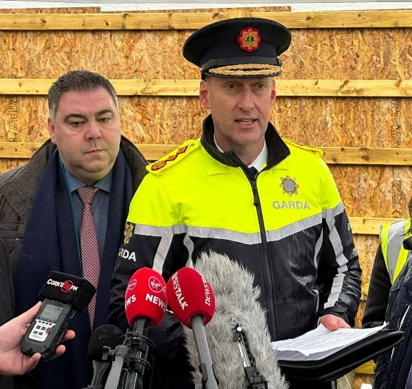
1Garda Commissioner Justin Kelly speaking to media at the site of the new Cork County Divisional Headquarters in Macroom, Co. Cork. John Paul O’Shea, TD also pictured

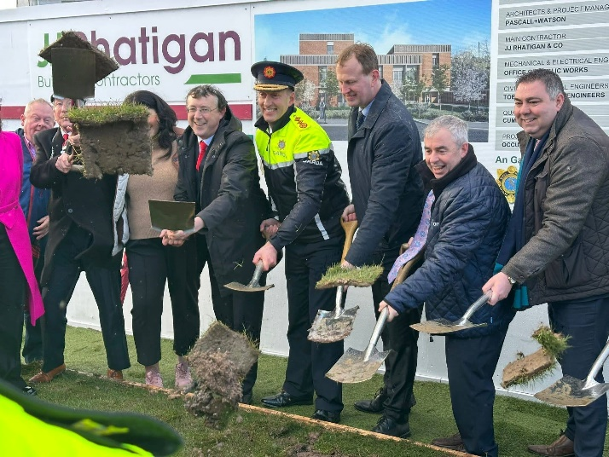
2Commissioner Kelly and Minister for Justice, Home Affairs and Migration, Jim O’Callaghan TD conducting the sod turning, together with Minister of State, Kevin Boxer Moran TD, Cllr Michael Looney, Cathaoirleach Macroom Municipal District, Senator Nicole R

Garda Commissioner Justin Kelly attended a sod turning event hosted by the Minister for Justice, Home Affairs and Migration, Jim O’Callaghan TD and the Minister of State with responsibility for the Office of Public Works, Kevin “Boxer” Moran, TD, to mark the commencement of the construction of the new Divisional Headquarters for Cork County in Macroom, Co. Cork. This highlights the significant investment being made in policing, community safety and public infrastructure for the Southern Region.

3. People and Development

The Strength of Garda Personnel
As at 28 February 2026, the Garda member strength stood at 14,529 and the Garda Staff strength stood at 3,679. A full breakdown by rank, grade and gender is outlined below.

Garda Attestation and Passing Out Ceremony held on 6 February 2026 at the Garda College, Templemore

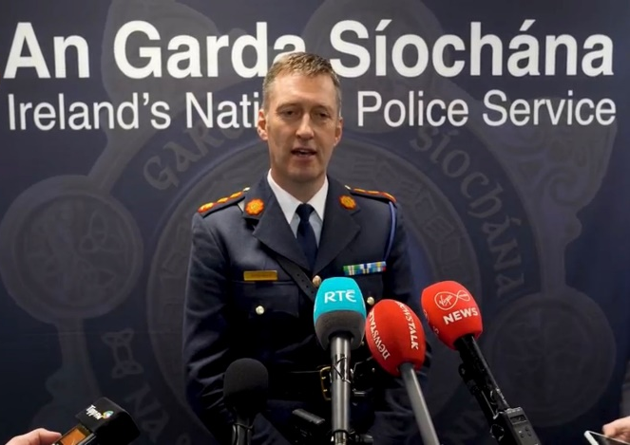
3Commissioner Justin Kelly speaking to media at the Garda College on 6 February 2026.
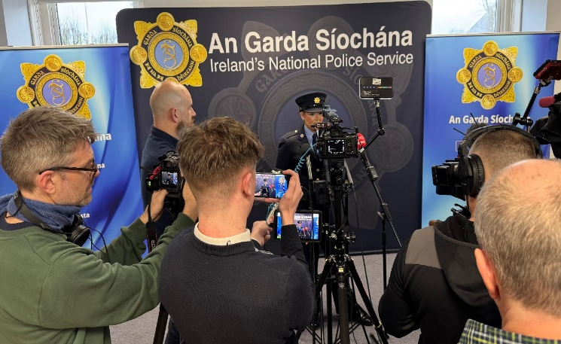
4 Newly attested Garda Rachel Smyth speaking to media at the Garda College on 6 February 2026.
An Garda Síochána welcomed 167 new Gardaí on 6 February 2026, following an attestation and passing out ceremony held in the Garda College. The Office of Corporate Communications was involved in promoting the passing out ceremony, which was also attended by the Minister for Justice, Home Affairs and Migration, Jim O’Callaghan TD. This included the issuing of a press release, conducting a live stream from the ceremony, associated photography and video content, together with a press briefing with Commissioner Justin Kelly and newly attested Gardaí at the Garda College in Templemore. These activities served to highlight the current strength of personnel in An Garda Síochána; that being a Garda is a job worth doing; and ongoing efforts in the area of recruitment.

Garda Member Strengths as at 28 February 2026

Rank | As at 28 February 2026 | Male | % | Female | % | WTE
Commissioner | 1 | 1 | 100 | 0 | 0 | 1
Deputy Commissioner | 1 | 0 | 0 | 1 | 100 | 1
Assistant Commissioner | 8 | 3 | 37.5 | 5 | 62.5 | 8
Chief Superintendent | 46 | 38 | 83 | 8 | 17 | 46
Superintendent | 165 | 133 | 81 | 32 | 19 | 165
Inspector | 479 | 381 | 80 | 98 | 20 | 479
Sergeant | 2,166 | 1,624 | 75 | 542 | 25 | 2,164.5
Garda | 11,663 | 8,157 | 70 | 3,506 | 30 | 11,629
Total | 14,529 | 10,337 | 71 | 4,192 | 29 | 14,493.5

Of which | As at 28 February 2026 | Male | % | Female | %
Career Breaks (incl. ICB) | 33 | 21 | 63.6 | 12 | 36.4
Work-sharing | 35.5 | 0.5 | 1.4 | 35 | 98.6
Secondments  (Overseas etc.) | 48 | 33 | 69 | 15 | 31
Maternity Leave | 51 | 0 | 0 | 51 | 100
Unpaid Maternity Leave | 29 | 0 | 0 | 29 | 100
Paternity Leave | 12 | 12 | 100 | 0 | 0
Available Strength | 14,320.5 | 10,270.5 | 71.7 | 4,050 | 28.3

Garda  Reserves Strength  28/02/2026 | Total | Male | % | Female | %
Garda  Reserves Strength  28/02/2026 | 308 | 237 | 77 | 71 | 23

Suspensions as of 1 March 2026
Total members suspended: 98
Male: 91 Female: 7

CURRENT MEMBERS ON SUSPENSION BY

RANK
Region | All
Suspension (Ended / Ongoing) | Ongoing
Rank | Total
Inspector Rank and above | 3
Sergeant | 11
Detective Garda | 55
Garda | 15
Probationer Garda | 1
Reserve Garda | 13
Grand Total | 98

CURRENT SUSPENSIONS & CORE ISSUES INVESTIGATED BY AGS & GSOC
Suspension (Ended / Ongoing) | Ongoing
Main Reason | Total
Driving under Influence of Intoxicant | 17
Fixed Charge Notice (FCN) Interference | 2
Other | 12
Corruption/Criminal Association | 8
Assault/Assault Causing Harm | 9
Domestic Violence/Coercive Control | 10
Theft/Forgery/Fraud/Dishonesty | 11
Sexual Assault/Sexual Misconduct | 16
Drugs/Drug Related | 4
Disclosure of Information/Data Protection/Abuse of PULSE | 9
Grand Total | 98

Suspensions
Year | New Suspensions | Lifted | Ended (Resignation /Retirement) | Dismissal | Total (Lifted/ Ended/ Dismissal)
2019 | 26 | 4 | 5 | 10 | 19
2020 | 41 | 6 | 9 | 0 | 15
2021 | 44 | 13 | 8 | 1 | 22
2022 | 44 | 11 | 7 | 1 | 19
2023 | 27 | 19 | 13 | 0 | 32
2024 | 18 | 21 | 13 | 1* | 35
2025 | 42 | 13 | 15 | 1 | 29
2026 | 6 | 9 | 3 | 2 | 14
* Section 17(4)B Criminal Justice (Corruption Offences) Act 2018 – Court Ordered

Garda Staff Strengths by gender as at 28 February 2026

Grade | Total | WTE | Male | % | Female | %
CCO | 1 | 1 | 0 | 0 | 1 | 100
Executive Director | 4 | 4 | 1 | 25 | 3 | 75
Chief Medical Officer | 1 | 1 | 1 | 100 | 0 | 0
Director | 3 | 3 | 2 | 66.7 | 1 | 33.3
PO | 30 | 30 | 16 | 53.3 | 14 | 46.7
AP | 123 | 123 | 59 | 48 | 64 | 52
HEO | 249 | 247.4 | 101 | 40.6 | 148 | 59.4
AO | 22 | 22 | 11 | 50 | 11 | 50
EO | 906 | 897 | 311 | 34.3 | 595 | 65.7
CO | 1,988 | 1,923.4 | 525 | 26.4 | 1,463 | 73.6
Total | 3,327 | 3,251.9 | 1,027 | 30.9 | 2,300 | 69.1
 | Total | WTE* | Male | % | Female | %
Professional/Technical (including Chief Medical Officer) | 71 | 70.8 | 34 | 47.9 | 37 | 52.1
Administrative *** | 3,326 | 3,250.9 | 1,026 | 30.8 | 2,300 | 69.2
Industrial/Non Industrial | 282 | 192.7 | 94 | 33.3 | 188 | 66.7
Total | 3,679 | 3,514.4 | 1,154 | 31.4 | 2,525 | 68.6
Of which | Total | WTE* | Male | % | Female | %
Maternity Leave | 24 | 24 | 0 | 0 | 24 | 100
Unpaid Maternity Leave | 9 | 9 | 0 | 0 | 9 | 100
Paternity Leave | 0 | 0 | 0 | 0 | 0 | 0
Available Total | 3,646 | 3,481.4 | 1,154 | 31.7 | 2,492 | 68.3
* WTE = Whole time equivalent – Garda Staff work on a number of different work-sharing patterns.
** Garda Staff Headcount is exclusive of Temporary Clerical Officers.
*** Civil Service grades and other administrative posts.

Work Sharing | Total | WTE | Male | % | Female | %
Work Sharing | 282 | 75.3 | 18 | 6 | 264 | 94
*** Work-sharing figure excludes industrial/non-industrial staff. Many posts are part-time.

Career Breaks**** | Total | WTE | Male | % | Female | %
Career Breaks**** | 24 | 24 | 7 | 29 | 17 | 71
**** Staff on career breaks are not included in total Garda strengths above.

Garda Staff Suspension figures as at 28 February 2026

CURRENT GARDA STAFF SUSPENSION & CORE ISSUES INVESTIGATED BY AGS
Main Reason | Total
Driving under Influence of Intoxicant | 1
Criminal charges | 2
Misconduct in role | 2
Disclosure of Information/Data Protection/Abuse of PULSE/breach of ICT policy | 2
Grand Total | 7

4. Corporate Communications
Throughout the month of February 2026, the Office of Corporate Communications continued to communicate internally and externally on a broad range of policing activities undertaken by An Garda Síochána.

Garda Press Office Activity
The Garda Press Office operates 7am-11pm, seven days a week, responding to hundreds of queries, coordinating external communications and media relations, and regularly updating our social media platforms.

This office issued 164 press releases, including 74 missing person appeals in respect of 31 individuals; 21 witness appeals; together with those related to operational activities and operations undertaken by the organisation during the month of February 2026.

Internal Communications
In February 2026, An Garda Síochána Internal Communications Team delivered seven comprehensive issues of Newsbeat, including one special feature edition which focused on the 30th Coiste Siamsa Sports Star Awards. The average Newsbeat open rate is 66%. This is higher than the industry standard open rate of 57.17% for internal newsletters, and the 52.26% average within Government and Public Service organisations.

5. Crime Trends

Crime Trends
The Garda Síochána Analysis Service closely monitors crime trends, and disseminates analysis on a national, regional and divisional basis. This feeds directly into planning operational activities aimed at reducing and preventing crime. Crime incident figures and the associated trends are based on provisional data, and are subject to change following review. The CSO publications represent the official crime statistics. These are carried in the CSO’s quarterly publications of crime trends and in their annual reports.

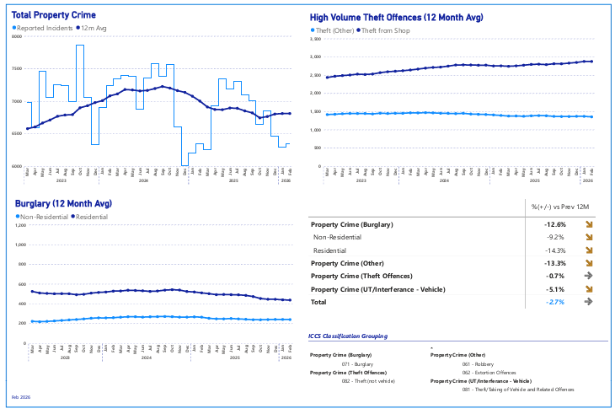

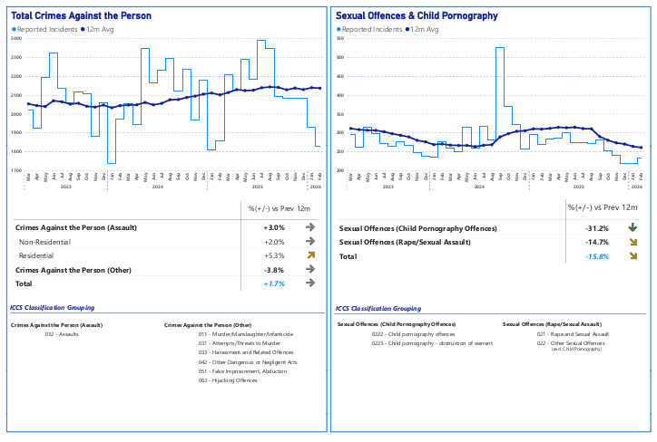
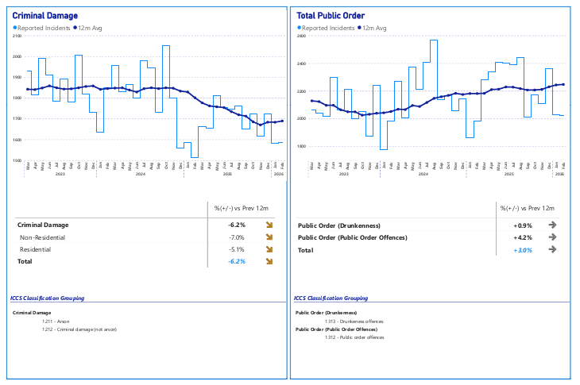

Use of Force February 2026

Use of Force Comparison – January 2026/February 2026
Category | Jan-26 | Feb-26 | Increase/ Decrease | % Change
Total UOF for Month | 1,220 | 1,177 | -43 | -4%
Civilians Injured | 22 | 21 | -1 | -5%
Garda Members Injured | 14 | 4 | -10 | -71%
Pepper Spray Deployed | 118 | 116 | -2 | -2%
Batons | 29 | 19 | -10 | -34%
Handcuffs | 1,066 | 1,033 | -33 | -3%
Anti-spit guard | 1 | 1 | 0 | 0%
Unarmed Restraint | 171 | 161 | -10 | -6%
Taser | 4 | 4 | 0 | 0%
Less Lethal Firearm | 2 | 1 | -1 | 50%
Firearm | 0 | 1 | 1 | NA
Gender Subject to Force - Male | 894 | 898 | 4 | 0%
Gender Subject to Force - Female | 137 | 125 | -12 | -9%
Drugs Involved | 338 | 317 | -21 | -6%
Alcohol Involved | 610 | 575 | -35 | -6%
Division with highest level UOF: DMR South Central | 192 | 190 | -2 | -1%
Percentage of UOF Deployments occurring Friday, Saturday & Sunday | 47% | 48.10% | 1.10%
This is operational information which may be subject to change.

Records indicate that in 2025, over 1,000 Gardaí in the course of their duties were assaulted, endangered, obstructed or were resisted when arresting a person. This will continue to be a focus for An Garda Síochána as we consider the impact of this on member’s availability and most importantly their wellbeing, as they go about their duties on a daily basis, keeping people safe. These records also indicate the need to keep close attention to the protective equipment available to our members.

6. Demonstrations and Events

An Garda Síochána continued to provide a policing response, including traffic management at protests/demonstrations, which continued to focus on themes of anti-immigration, associated accommodation and international conflict.
Table 2 - Demonstration (Non Crime) – Feb 2026
Region | Feb 2026
Dublin Region | 73
Eastern Region | 8
North Western Region | 5
Southern Region | 12
Grand Total | 98

Table 1 - Demonstration (Non Crime) - 2026
Region | 2026
Dublin Region | 165
Eastern Region | 11
North Western Region | 6
Southern Region | 30
Total | 212

Data as was present on the PULSE database on the morning of 3 March 2026 was drawn down, tallying all incidents of Type Demonstrations (Non Crime), barring invalid incidents between 01/01/2026 and 28/02/2026. The data contained herein is operational and subject to change.

The impact of international conflict continues to be a consideration for policing in this jurisdiction. We will continue to maintain and develop our international collaboration.

7. Roads Policing

An Garda Síochána continues to respond to road safety challenges. In February 2026, 12 people died in fatal collisions. There were 54 serious injury collisions reported in February 2026. An Garda Síochána continues to implement the 30-minute roads policing initiative, which was introduced in April 2024 to increase visibility on our roads. In February 2026, there were 3,927 MIT checkpoints conducted. There was an average of approximately 12 arrests per day nationally for driving under the influence of drugs, 13 per day for driving under the influence of alcohol and more than 3,100 vehicles seized under the provisions of Section 41 of the Road Traffic Act, in February 2026.

 |  | February 2026
Mobile Phone FCNs |  | 2,135
Seatbelt FCNs |  | 415
Intercept Speed FCNs |  | 4,033
Non-Intercept Speed FCNs |  | 14,579
Total Speed FCNs |  | 18,612
E-scooter FCNs |  | 141
Driving While Intoxicated* |  | 677
Driving While Intoxicated - alcohol as a factor |  | 342
Driving While Intoxicated - drugs as a factor |  | 303
Driving While Intoxicated – alcohol & drugs as a factor |  | 32
Section 41 Detentions |  | February 2026
Vehicle Detained (Sc. 41 RTA)** |  | 3,111
Vehicle Detained (Sc. 41 RTA) - no ins. |  | 1,658
Vehicle Detained (Sc. 41 RTA) - no tax |  | 1,021
Vehicle Detained (Sc. 41 RTA) - no NCT |  | 506
Vehicle Detained (Sc. 41 RTA) - unaccompanied learner drivers |  | 787
MIT Checkpoints - Breath/Oral Fluid Tests |  | February 2026
MIT Checkpoints - Breath Tests performed |  | 14,891
MIT Checkpoints - Oral Fluid Tests performed |  | 905

* Driving While Intoxicated excludes incidents of type ‘Driver Under the Limit (No Offence Disclosed)’ and ‘In Charge Under the Limit (No Offence Disclosed)’.
** It is important to note that vehicles may be detained under S.41 of the Road Traffic Act for more than one reason.
Information contained in this section is based upon operational data from the Pulse and FCPS systems as was available on 02/03/2026 and is liable to change. Crime counting rules were not applied.

Operation conducted in the Eastern Region into the non-compliance usage of E-Scooters and E-Bikes
On 27 and 28 February 2026, Gardaí conducted an operation into the non-compliance usage of e-scooters and e-bikes by members of the public in the Eastern Region. This operation was conducted following concerns being raised by members of the public of these vehicles being used on footpaths, public roads and in parks. During the course of this operation, 18 e-scooters/e-bikes were seized for non-compliance, with one of these e-bikes capable of travelling at a speed of up to 100km/h.
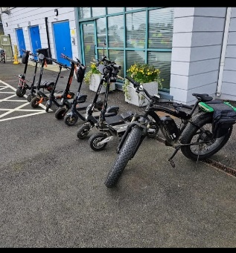
5 Seized E-Scooters and E-Bikes.

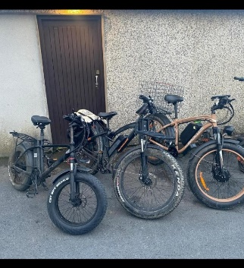
6Seized E-Scooters and E-Bikes.

8. Prevention and Disruption of Crime

Presentation provided to the Swedish Police on the Irish Youth Justice system
A presentation to Swedish Police on the Irish Youth Justice System was held in February 2026 at Sörentorp Police Training Academy near Stockholm. The invitation to present on the Diversion Programme and the Irish approach to youth justice arose as a result of previous participation at a European Union Crime Prevention Network (EUCPN) Expert Meeting on prevention of the recruitment of children by organised crime held in Stockholm in May 2025.

Approximately 40 Swedish Police Officers participated in the conference, which involved the delivery of presentations and discussions on the Garda Youth Diversion Programme, the role of the Juvenile Liaison Officer and the supports provided to offenders between the ages of 12 and 15. The participants were particularly impressed with the community focus of An Garda Síochána, including our focus on crime prevention. The status of the Diversion Programme and the allocation of dedicated resources to ensure its implementation received positive comment. The full time nature of the role of the Juvenile Liaison Officer, the status they have in the community and their child-centred focus were also highlighted as real positives of the Irish system.

It is clear that the Garda Youth Diversion Programme and the role of the Juvenile Liaison Officer is viewed as an example of best practice in youth justice within the European Union, with states such as Sweden wishing to learn from the Irish experience and approach to youth justice.

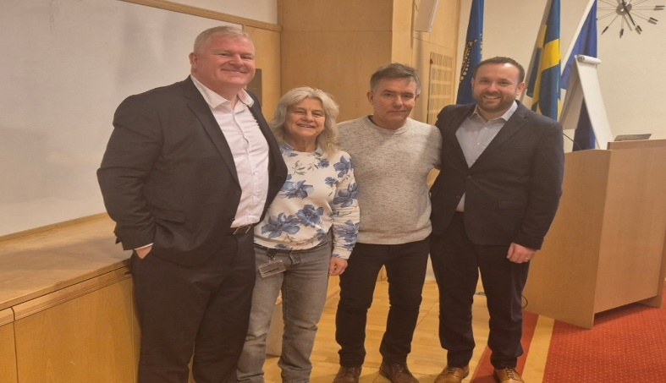
7Left to right – Superintendent John Finucane, Kommissarie (Superintendent) Cataharina Tornqvist, Kommissarie (Superintendent) Johan Sone and Inspector Daniel MacGinty.

High Visibility Policing on Public Transport in the Dublin Metropolitan Region
While continuing a high visibility presence to prevent and detect crime and anti-social behaviour, we maintained a strong presence in our main urban centres, including Dublin.

On 6 February 2026, Gardaí conducted a day of action across the Dublin Metropolitan Region under Operation Saul. Buses on a number of routes were boarded during high visibility beat patrols. Gardaí liaised with Dublin Bus inspectors, engaged with drivers and members of the public, to assure commuters and workers of their safety while using public transport. Some incidents occurred which required a direction under Section 8 of the Criminal Justice (Public Order) Act, 1994, all of which were complied with, without further escalation. A number of fixed charge penalty notices for road traffic offences were also issued.

Garda National Cyber Crime Bureau (GNCCB)
The Garda National Cyber Crime Bureau (GNCCB) operates under the command of Assistant Commissioner, Organised and Serious Crime. Headed by a Detective Chief Superintendent, the remit of GNCCB includes providing a computer forensic service to its members and units, the investigation of cyber-dependent crimes that target significant or complex attacks on computer systems, corporate networks or critical national infrastructures, and the provision of cyber safety and prevention advice to all sectors of industry and the community.

On 3 February 2026, Detective Superintendent GNCCB presented at the CyberEX Experts Conference, Hong Kong on the subject of the ‘Industrialisation of Financial Sextortion’. In mid-February, Detective Chief Superintendent GNCCB attended at the offices of the Directorates-General (DG) Home in Brussels, where he delivered a presentation to the heads of all DGs on issues from a law enforcement perspective resulting from privacy and encryption. Meanwhile in Ireland on 24 February 2026, Detective Gardaí from Walter Scott House and the other nationwide hubs assisted the Garda National Economic Crime Bureau with the search of a number of properties to target an organised crime group linked to theft and money laundering. GNCCB published the booklet, ‘Social Media User Safety Guide’, which can be downloaded from the Garda website and the portal. Printed copies have been distributed to the regional hubs.

9. Community Engagement

Safer Internet Day 2026
On 10 February 2026, the Garda National Community Engagement Bureau and members from the Garda National Protective Services Bureau attended Safer Internet Day 2026, hosted by Webwise at the Department of Justice, Home Affairs and Migration. The theme for this year was ‘AI Aware: Safe, Smart and in Control’. The theme of the event is to bring together key stakeholders to explore ways to help children and young people be safe and responsible in a world increasingly shaped by Artificial Intelligence (AI) tools and digital technology. Key speakers included Dr Mhairi Aitken, Senior Ethics Fellow at The Alan Turing Institute (the UK’s national institute for AI and data science) and Professor Sonia Livingstone. Discussions included the benefits and consequences of AI. There was much focus on how our younger generation feels about AI technology and how it directly impacts them as they grow up in tandem with fast developing AI technology.

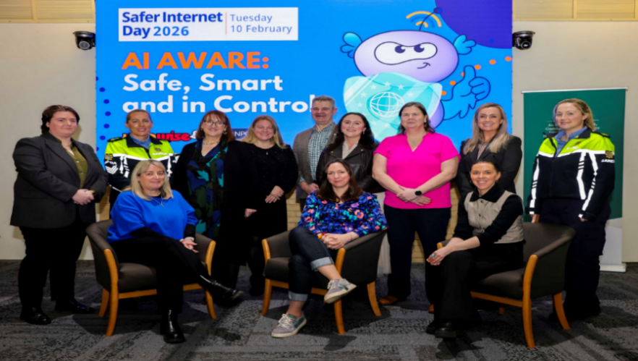
8Photograph left to right: Detective Sergeant Laura Burke Sergeant Paulina Szramowska, members from Department of Justice, CEO Hotline- Mick Moran, Detective Sergeant Cathy Curtain, Detective Superintendent Sinead Greene (National Protective Services Bure

Community Policing Unit in the North Western Region provide Road Safety presentation
The Brothers of Charity Services provides a wide range of services to people with an intellectual disability and their families across the North Western Region. A dedicated road safety presentation tailored to the needs of the attendees was completed by the Community Policing Unit on 13 February 2026, for the Youthways and Oakley Day Services groups. As a result of this event, the group submitted a report to highlight their concerns regarding issues faced locally in terms of road safety, and to highlight issues for pedestrians and wheelchair users, which have also been raised with local politicians and planning sections.

Presentation by the Garda National Diversity Unit to IPAS Centre residents
The Garda National Diversity Unit, in conjunction with Community Policing members from the Dublin Metropolitan Region, presented to International Protection Accommodation Service (IPAS) Centre residents in North Dublin. The topics covered included the roles of the National Diversity Unit and Garda Diversity Officers, identifying and reporting hate crime, Irish legislation, reporting online content and road safety.

