Traffic Management Plan
Munster V Leinster
Guinness Pro-14
Thomond Park, Limerick – Saturday 29th December
Kick Off 17.15hrs
________________________________________________________

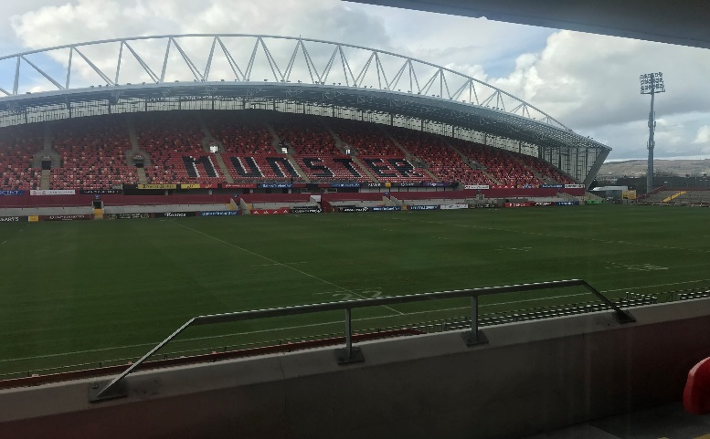

Introduction:

An Garda Síochána, Limerick are delighted to welcome all supporters to Limerick for Munster V Leinster at Thomond Park Stadium on Saturday 29th December 2018. In order to maximise your enjoyment of the match An Garda Síochána would like to offer the following information in relation to traffic management and safety at the match in Thomond Park.
GENERAL TRAFFIC ARRANGEMENTS

1. Thomond Bridge / Sarsfield Bridge and New Shannon Bridge will remain open to Two Way Traffic throughout the event.

2. Traffic travelling out bound (N7) on Sexton Street North towards Old Cratloe Road and past the stadium or intending to turn right at Hassetts Cross northbound along Kileely Road(R464) will not be restricted but due to volume, delays can be expected from as early as 15.15hrs. Similarly, traffic travelling outbound on N18 can expect to experience delays also.

3. No general parking spaces are available within the grounds and vehicle access to the grounds (this includes access for vehicles with special needs) is limited by Pass Only issued by Stadium Management. Parking restrictions will be put in place near the Stadium for local residents. Vehicles found in breach are liable to be impounded.

4. Pre match Road closures and diversions as set out below will come into effect at 14.30hrs and will remain in place until at least 1900hrs. Where road closures / diversions apply all public services vehicles [including taxis / hackneys] buses / minibuses and specially adapted [disabled] vehicles and vehicles with Residents Permits will be allowed proceed beyond the road closures.
Diversions
Traffic travelling inbound along the Ennis Road and intending to turn left at Ivan’s for Northern Ring Road (N7) (Brookville Avenue) and travelling North bound from Clonmacken Road intending to proceed towards Northern Ring Road (N7) (Brookville Ave) can expect delays and are subject to volume of patrons attending event liable to be diverted on Ennis Road at Ivan’s Shop, Caherdavin.

Traffic travelling inbound (R464) from Parteen, Moyross, Long Pavement direction will be diverted left onto New Road subject to volume of patrons attending event, Kileely and may be subject to delay / diversion.

Road Closures:

Road Closures will apply from 14.30 hrs onwards at the following locations;
- Mayorstone Drive at its junction with Avonmore Road
- Shelbourne Road Upper at its junction with Shelbourne Park
- Shelbourne Road Upper at its junction with Mayorstone Drive
- Old Cratloe Road at its junction with Mayorstone Avenue
- Old Cratloe Road at its junction with Mayorstone Upper
- Old Cratloe Road near its junction with Merval Drive
- Kileely Road at its junction with Ballynanty Road

The Old Cratloe Road – Cratloe Road Roundabout to Hassett’s Cross and Shelbourne Road – Hassett’s Cross to Union Cross will be closed to all traffic (for approx 30 minutes / half an hour) on termination of the Match to permit the safe egress of patrons from the Stadium.

Parking;
The Garda advice to patrons is to arrive early and to avail of city centre on-street parking and also of parking available at city centre car parks.

Patrons can also walk to the stadium (15-20 mins from the City Centre), avail of the Bus Service from the city or avail of Park and Ride services.
Patrons requesting wheelchair accessible parking are advised to contact the Ticket Office at Thomond Park in relation to parking available in the area.
Crime Prevention:
Gardaí would like to advise patrons to be aware of their own personal safety and security while attending the event;
Event Organiser:
The Event Controller is Colm Moran, his contact details are cmoran@thomondpark.ie

