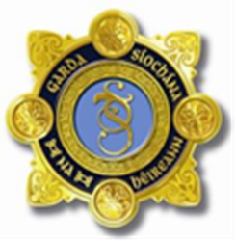

Traffic Management

LIMERICK GAA HOMECOMING EVENT
20th August 2018
Gaelic Grounds Limerick

Press Release
Traffic Management
A homecoming celebration takes place in Limerick City on the 20th August to celebrate the All-Ireland Hurling Champions returning to the city.

In order to maximise everyone’s enjoyment of the day a number of temporary road closures will be in place from 3.30 pm. The road closures are in place to ensure that there are ample safe viewing points of the team as they pass through the city.

Garda advice to patrons is that the event in the Gaelic Grounds is sold out and you will therefore not be permitted to enter the stadium or its environs without a valid ticket. Those who do have tickets are asked arrive in plenty of time for the event. With the gates scheduled to open at 4pm. There will be no parking in the Gaelic Grounds environs. Cars illegally parked will be ticketed and those causing obstruction are likely to be towed away by Gardai. Patrons are advised to consider walking to the stadium from the nearby city centre car parks.

To facilitate those who do not have a ticket for the Gaelic Grounds, the team will parade on an open top bus departing from Colbert Train Station at 6pm, travelling down Mallow Street turning right onto O Connell Street, travelling contraflow down to Sarsfield Street and turning left to go out over Sarsfield Bridge, continuing out the Ennis Road to arrive at the Gaelic Grounds at 7pm. This route will offer a fantastic opportunity for members of the public to show their support for the victorious team.

The following road closures and diversions will be in place from 3.30pm on Monday 20th August 2018.

Closures/Diversions:
The following road closures will be in place from 3.30pm to 9.00pm.
- The Ennis Road (R857) will be closed to vehicular traffic and parking between Sarsfield Bridge and Ivan’s Cross (R445). Local Diversions will operate.
- Residential access to Mayorstone, Coolraine Estate, Merval Park and adjoining areas will be subject to road closures from 1.00pm with residential access only permitted.
- Motorists are also advised that Limerick city centre will be subject to significant traffic diversions, with rolling closures from 5.30pm until 7.30pm due to the homecoming of the victorious Limerick Hurling team. Traffic delays are expected.

If you are driving to the city the Gardaí would appeal to patrons to keep to the speed limits, never “Drink & Drive”, “Text & Drive” or “Phone & Drive”

Parking:

The area around the Gaelic Grounds will remain clear of vehicles to allow for patrons who are on foot approaching the stadium. There is no parking available near the grounds and the advice is to use the City centre car parks and to arrive before the road closures are in place.

Patrons driving to the city should expect delays in Limerick as the team pass through the city

Gardaí would like everyone to enjoy this occasion and would advise anyone travelling to event to arrive in plenty of time for the event. The last entry to the Gaelic Grounds will be at 6.30pm

Crime Prevention Advice

An Garda Síochána would like all patrons travelling to the celebration to keep safe so here are a few tips for those attending the homecoming

- Don’t leave any valuables in your vehicle and if you must, keep them out of view. This should be done before you get to your destination.
- There are likely to be large crowds at the homecoming so parents should exercise caution and be aware of their child’s whereabouts at all times.
- Garda members will be in possession of public safety wristbands for children and vulnerable people who are attending the match. We would advise parents to write their numbers on these wristbands.
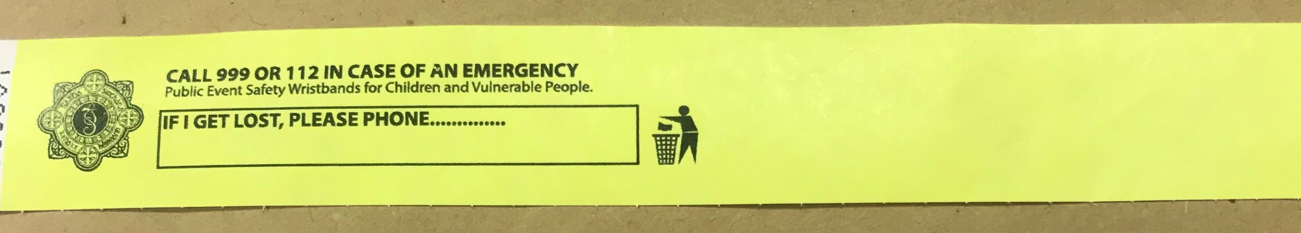

Patrons are also reminded that parking of cars on any green areas in the City, particularly in the Clonmacken and Caherdavin areas is NOT PERMITTED and there is Signage in these areas. Offending Drivers are liable to have their cars ticketed or towed.

Do not park illegally - your actions may have consequences for Emergency Vehicle Access or cause damage to the local amenity

