Garda Concert Management Arrangements for Croke Park

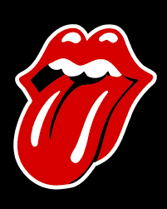

Re: The Rolling Stones in Concert at Croke Park Stadium.
Thursday 17th May 2018.

Stiles Opening : 17.00hrs.
The Academic : 19.00hrs
The Rolling Stones : 20.00hrs.
Event Finish : 23.00hrs.

Public Transport:



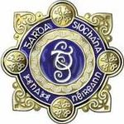

In conjunction with the Transport Agencies attached Gardai have developed a transport plan to assist patrons attending THE ROLLING STONES Concert at Croke Park Stadium.

For full details of all public transport please see :
- National Journey Planner
- www.dublinbus.ie
- www.luas.ie
- www.irishrail.ie
- www.buseireann.ie
- www.crokepark.ie

Persons attending are advised:

The advice from all agencies involved in the management of the concerts is to utilise public transport for travelling to and from the concerts and use park and ride facilities.

Public Transport Information

On Thursday 17th May 2018, Iarnród Éireann will provide additional capacity on DART and Commuter routes for fans attending THE ROLLING STONES concert in Croke Park Stadium.

Additional Late Night DART & Commuter Services :
- Additional services will operate to Greystones, Howth and Maynooth* after the concert.
- These additional services along with all regular services can be viewed through the journey planner.

Additional Late Night Intercity Services : Please check www.irishrail.ie for up to date information .

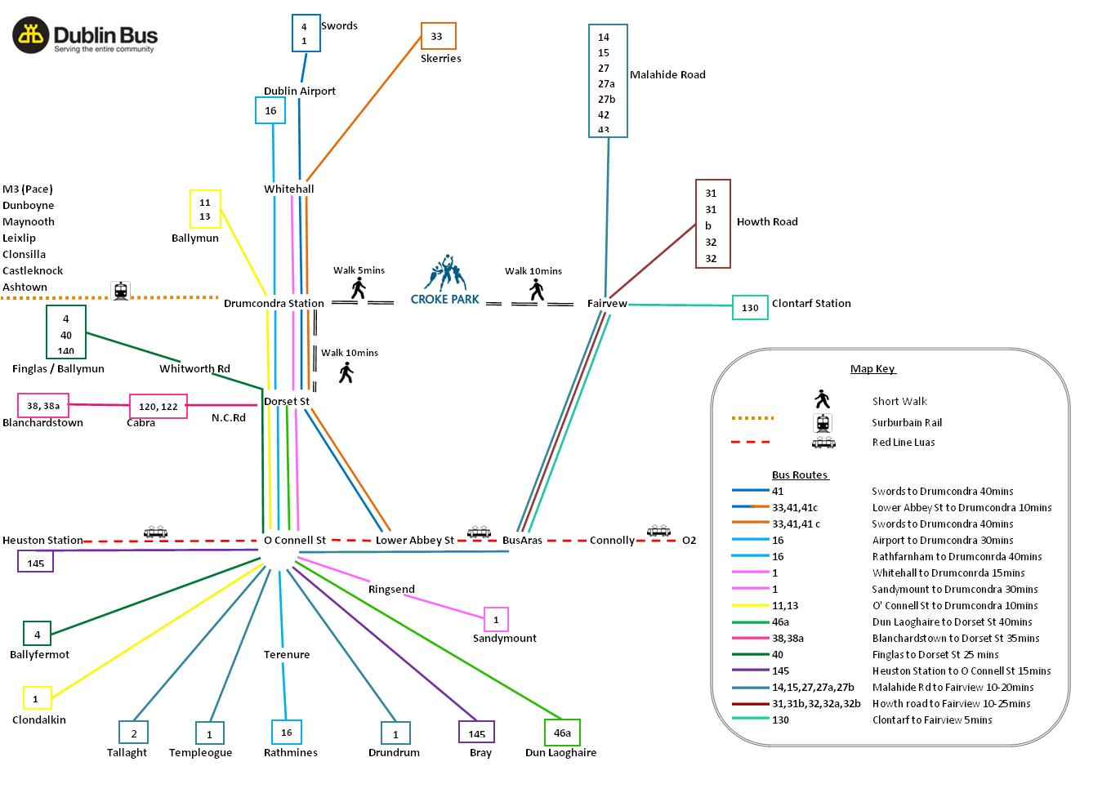
Dublin Bus routes servicing Croke Park Stadium and its immediate environs.
For more information contact Dublin bus at www.dublinbus.ie

THE ROLLING STONES / Croke Park

Concert Parking Offer -

- Concert Parking at selected Park Rite car parks
- Bring your concert ticket to the car park office to avail of the Park Rite Croke Park event offer or pre-book online at www.parkrite.com
- Offer does not include overnight parking
- All car park locations are 10 – 15 minute walk to Croke Park
- Enquiries to 01-5425600.

Park Rite Parnell Street Car Park, Parnell St, Dublin 1 Spaces: 500

Opening Hours: Monday to Thursday 6.30am to 00.30am, Friday 6.30am to 1.30am, Saturday 7.00am to 1.30am, and Sunday 9.30am to 00.30am.

Park Rite Irish Life Car Park, Lower Abbey St, Dublin 1 Spaces: 340

Opening Hours: Saturday 22nd July8.00am to Midnight.

Park Rite IFSC Car Park, Commons St (rear of Jury’s Inn) , Dublin 1. Spaces: 370

Opening Hours: Saturday 22nd July 8.00am to Midnight.

Park Rite Fleet Street Car Park, Temple Bar, Dublin 2 Spaces: 393

Opening Hours: 24 Hours a day seven / days a week.

Park Rite Drury Street Multi-Storey Car Park, 36-37 Drury St, Dublin 2 Spaces: 465

Opening Hours: Monday to Saturday only 05:30 to 02:00.

Park Rite Smithfield Car Park, Queen St, Dublin 7 Spaces: 348
(ONLINE PRE BOOK ONLY at this car park)

Opening Hours: Monday to Friday 7.00am to 1.30am, Saturday 8.00am to 1.30am, Sunday/Bank Holidays 10.00am to Midnight.

Luas

P&R Red Line:
- Red Cow – 727 spaces (24 hr access)
- Cheeverstown (312) (24 hr access)
- Last Luas 00:30hrs

P&R Green Line:
- Balally 421 spaces(24 hr access)* price subject to change
- Stillorgan 341 spaces (24 hr access)
- Sandyford 47 spaces (24 hr access)
- Carrickmines 352 spaces (24 hr access) * price subject to change
- Last Luas 00:30hrs

Operating hours: Green Line
Broombridge to Brides Glen
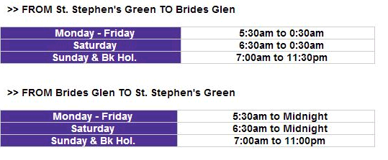
Brides Glen to Broombridge

Operating hours: Red Line
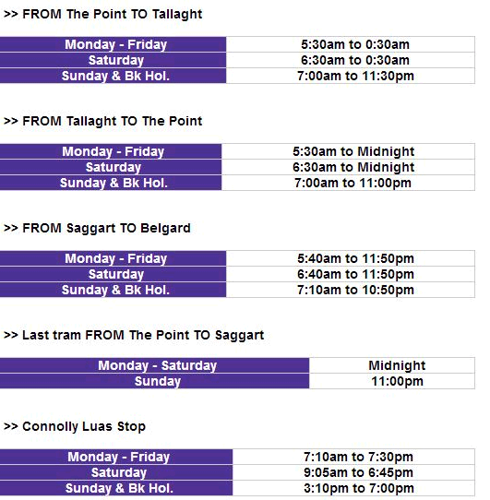
For further information contact Luas at www.transdevireland.ie

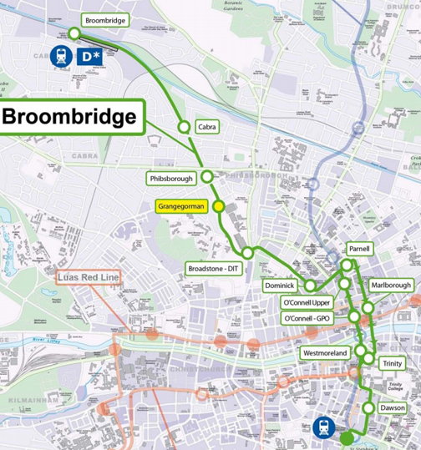

General Concert Information.

Ticket Collections :

There are still ticket sales for this concert. Please refer to www.ticketmaster.ie for details of ticket collections for this concert.

Residents :

Patrons are requested to be aware that Croke Park is located in a residential area. Patrons attending Croke Park are requested to respect residents by behaving in an appropriate manner when going to and departing the stadium. Issues such as illegal parking, anti social behaviour, drinking and urinating in public cause difficulties and will not be tolerated by Gardai. Patrons are asked to desist from such behaviour.

Jones Road :

Jones Road will remain sterile throughout the concert. This restriction will be strictly enforced. All non ticket holders are requested not to congregate on the streets around the stadium.

Banned Items in Stadium

A: The below items are not allowed:
- Aerosols / Air Horns
- Animals (Other than registered guide or hearing dogs)
- Alcohol
- Any item which may reasonably be considered for use as a weapon
- Audio recorders
- Backpacks / large bags / Waist packs
- Banners with poles or poles of any kind
- Bottles
- Cans
- Cooler Boxes or Large containers
- Crash helmets or protective headwear, body armour or protective clothing
- Drumsticks
- Excessive amounts of batteries, wire, cables or electrical components
- Fireworks or flares
- Flagpoles
- Glass
- Glow sticks
- Illegal substances/ illegal merchandise of any description
- iPads
- Umbrellas
- Large chains, spiked bracelets or wallet chains
- Large Flags, Placards or Posters inc. sticks
- Lasers / Laser pens or torches
- LED Headbands, wristbands, Glow sticks or Light emitting objects of any kind (except mobile/cell phones)
- Liquids - No liquids are permitted other than sealed water less than 500ml is allowed (Caps will be removed)
- Selfie sticks
- Smoke canisters
- Sound systems
- Spray cans
DO NOT BRING BACKPACKS OR LARGE HANDBAGS

THERE WILL BE NO CLOAKROOM OR STORAGE FACILITIES ON SITE.
BAGS MUST NOT BE LEFT AT ENTRANCES OR SURROUNDING AREAS. ANY ITEMS LEFT WILL BE REMOVED AND DISPOSED OF ACCORDINGLY.
Should you require somewhere to store a backpack, large handbag or any additional luggage during the event the following locations have Bag drop/locker storage facilities available (please note these are independently run facilities)
• Ned Kelly’s: 43 O' Connell Street Upper
• Abbey Court
• Busáras station opposite Connolly train station
- Access Baggage: Dublin Airport

Searching is a condition of entry to protect your safety and that of others.
Due to increased security measures we strongly advise you allow sufficient time to get through security checks to gain entry to the venue in a safe and timely manner.
To ensure as smooth an access as possible and to avoid any unnecessary delays we strongly suggest that you bring as little as possible with you to the event and minimize jackets and additional layers when possible. To avoid disappointment do not bring backpacks or larger handbags, you may be refused admission to the venue without a refund.
We recommend if you are bringing personal bag, purses or clutch bag, you should only bring those of smaller sizes i.e. A 5 size those measuring 4.5in/11.4cm x 6.5in/16.51cm or smaller will be allowed. i.e.
We will also conduct additional further security searches “Pat down search “by trained security personnel of clothing, bags and other items, as determined by us in our reasonable discretion, including on entry and exit

Crowd Management and Crowd Dispersal Plan

Pre Concert Crowd Management Plan :

In the interest of safety patrons are advised as follows:

- Not to enter the Jones Road / Russell Street unless they hold a Hogan Stand or Premium ticket.
- Not to congregate in vicinity of Croke Park Hotel as this causes a serious obstruction to crowd movement in that area. Gardai will move waiting persons in this area.
- Use coloured routes outlined on Croke Park / Aiken websites to access the stadium.
- Arrange meeting points at a distance away from Jones Road.

Post Concert Crowd Management Plan:

In the interest of safety patrons are advised as follows:

- Patrons exiting the Hogan Stand will be directed to exit by a planned route as they leave these stands onto Jones Road.
- Patrons are further requested not to congregate in vicinity of Croke Park Hotel as this causes a serious obstruction to crowd movement in that area. Gardai will move waiting persons in this area.
- Patrons exiting via Clonliffe Road and via North Circular Road are asked by Gardai not enter onto Jones Road or Russell Street.
- Please arrange to meet friends at a place a distance away from Jones Road.

Patrons should comply with the directions issued by Gardaí and stewards as they depart the stadium. The measures are being implemented to prevent crowd congestion on the street outside the Croke Park Hotel which has become a meeting point for patrons attending Croke Park concerts.

The result of patron active participation and compliance will result in a safer entry and exit from the stadium for all patrons and children and make the stadium environs a safer place for all people.

General Traffic Advice :
Traffic Restrictions

Barriers will be erected at the following locations at 3pm and only authorised traffic will be permitted to access.

- North Circular Road / Russell Street
- Lower Drumcondra Road / Whitworth Place.
- Lower Drumcondra Road / Fitzroy Avenue.
- Clonliffe Road / Jones Road.
- Clonliffe Road / St Joseph’s Avenue.
- Clonliffe Road / St James Avenue
- Ballybough Road/ Foster Terrace.
- Ballybough Road / Sackville Avenue.
- Ballybough Road / Clonliffe Avenue A
- Ballybough Road / Clonliffe Avenue B
- Ballybough Road / Ballybough Bridge

In addition to the above barriers will also be erected at the following locations at 4pm closing the remainder of streets to form full Garda Cordon.

Clonliffe Road 4pm Closure

- Lower Drumcondra Road / Clonliffe Road.
- Ballybough Road / Clonliffe Road.
- North Circular Road/ Belvedere Avenue.
- North Circular Road/Lower Sherrard Stree
- North Circular Rd /Portland St
- Lower Drumcondra Rd / Binns Bridge
- Lower Drumcondra Road / Clonliffe College entry laneway.
- North Circular Road/ North Charles Street/ Mountjoy Parade.
- North Circular Road / Richmond Street North.
- North Circular Road / St Margaret’s Avenue
- Mountjoy Square East / Fitzgibbon Street.

North Circular Road will close at 7pm at North Circular Rd North Charles St and North Circular Rd Belvidere Rd and traffic will be diverted around this section of North Circular Rd

The following road closures will be implemented in order to restrict all traffic movement into Mountjoy Square and allow for traffic flows in both directions on North Circular Road. The closures outlined will be removed where a decision to close North Circular Road is required.

- Gardiner Street / Mountjoy Square North.
- Gardiner Street / Mountjoy Square South.
- Gardiner Street / Belvidere Court

Garda Traffic Control Centre:

Traffic Control Centre, Garda Communications Room Harcourt Square will be operational during the event and Gardai from Regional Traffic Unit, Dublin Castle will be on duty there. The Control Centre will make full use of the S.C.A.T Traffic light system to regulate the flow of traffic. Sgt I/C Phone - 01-6663146 / 6663147 / 6663149
The Garda Communications Room at Croke Park will liaise directly with the above Gardai to high-light areas requiring immediate attention. Garda cordon personnel and traffic vehicles will be utilised to assist with all traffic matters.

Parking Arrangements :

There are two supervised car parks available in the immediate vicinity of Croke Park.

- O’Connell’s School, North Richmond Street / 300 Spaces including 10 Special Needs Parking spaces.
2. Clonliffe College, Clonliffe Road / 2,000 Spaces including 100 Special Needs Parking spaces.

Traffic will not be permitted to exit the car parks for a period after the Concert ends in order to allow pedestrians to depart the area safely.

Special Needs Parking:

There are no special needs parking facilities on the public streets within the Croke Park cordon area or within the stadium. Special needs parking is provided at the supervised car parks as outlined above.
Where persons have special needs requirements they should contact Aiken / Croke Park directly at www.crokepark.ie for advice and assistance.

Public Transport Initiative:

The public transport initiative includes use of Train, Bus and Luas services. There are also a number of park and ride facilities being provided in the city suburbs with connecting services to and from Croke Park Stadium.

Traffic Plan for Private Bus / Coaches:

Gardai will invoke power under Section 91 R.T.A. to lift the cycle lane at Alfie Byrne Road to allow for bus drop off pre-concert and bus pick up post-concert 6pm to 11pm.

A dedicated parking facility is being provided for private bus / coaches at Alfie Byrne Road. Drivers have been advised to go directly to Alfie Byrne Road and their passengers to disembark there. They are to remain there until the return of their passengers following the concert. They have been advised to use one of two dedicated routes:
- M50 and the Port Tunnel
- M11 and East Link Bridge.

All patrons and coach operators have been advised that there is no coach parking facilities in the environs of Croke Park Stadium. Coaches will not be permitted to drop/collect patrons on Jones Road, Clonliffe Road, Lower Drumcondra Road and Ballybough Road or stop for this purpose on any of the major traffic arteries.

This restriction will be strictly enforced by the Garda Traffic Corps and coach drivers are requested to comply with this instruction for the safety of their passengers and other road users.

The bus/coach parking facility at Mountjoy Square is not available for the concert. The bus/coach parking facility at Western Way (off Phibsboro Road) is available for this event. This is a very limited facility and parking will be on a first come first served basis. Please ensure that you comply with parking regulations. Double parking of buses will not be permitted. Drivers are also requested to turn off engines while parked there.

Post Event Traffic Restrictions:

The Garda cordon outlined will be extended at the end of the event to facilitate the safe exit and dispersal of concert patrons. These closures will be implemented for the shortest time necessary. Vehicles will not be permitted to access the Garda cordon during this exit period in order to ensure the safety of pedestrians and vehicles alike.

As a guideline this extended cordon will be in place for approximately 3/4 hour after the concerts end.
- North Circular Rd and Belvadere Rd & North Circular Rd and North Great Charles St may close (pre & post concert)
- Ballybough Road will also be closed post concert from the Clonliffe House to the junction of North Circular Road/Summerhill to allow patrons to safely egress from the Cusack Stand side of the Stadium
- All inbound Traffic on Fairview may be diverted towards the city away from Ballybough
- All outbound Traffic on Parnell St. will be diverted left and right at Gardiner St away from Summerhill / Ballybough Area

For the purpose of this closure, Garda Motor Cyclists will be deployed at the following locations closing the streets as outlined
- Lower Drumcondra Road / Whitworth Road. (Outbound )
- Lower Drumcondra Road / Richmond Road/ Botanic Avenue. (Inbound)

The above restrictions will result in the closure of Lower Drumcondra Road from Whitworth Road to Botanic Ave

- Ballybough Road / Luke Kelly Bridge
- Poplar Row / North Strand Road.
- Summerhill / North Circular Road.

Dublin Bus will be facilitated in passing through this closure to assist with patron transport. Dublin Bus will have an Inspector in attendance to assist with same.

Vehicle Access Routes :

All patrons attending the concerts by vehicle are advised to allow time for traffic delays.

Patrons who have tickets for the Hogan and Davin Stands should approach from the west and north side of the stadium by using the M50 motorway to Navan Road, Finglas Road and Drumcondra Road.

Patrons who have tickets for the Cusack Stand and Pitch should approach from the east and south side of the stadium by using the Port Tunnel and East Link Bridge. Dublin Port Tunnel will be open to all vehicles.

On street parking is very limited due to Croke Park being situated in residential area. Patrons should be aware that illegally parked vehicles cause traffic disruption, and obstruction to movement of emergency vehicles.

There will be strict enforcement of all illegal parking in the area by Gardai and Dublin City Parking Services and such vehicles will be impounded or clamped and will be liable to a substantial fine.

Car Parks :

There are two confirmed supervised car parks available in the vicinity of Croke Park.

- O’Connell’s School, North Richmond Street. Entry via North Circular Road.

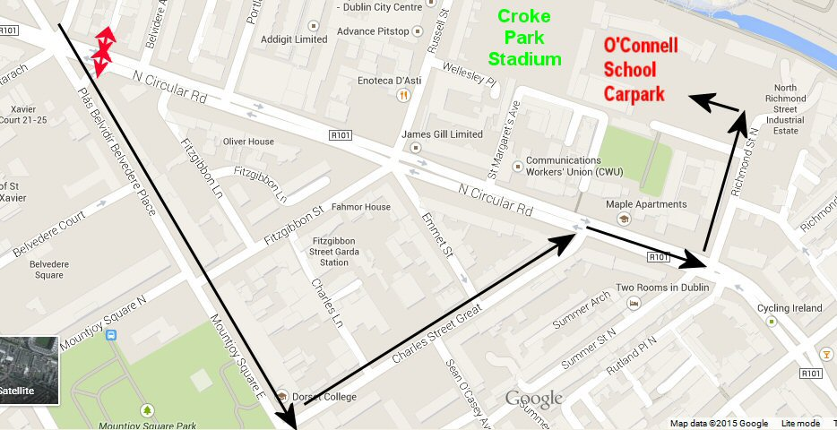

- Clonliffe College car park, Entry via Drumcondra Road.
This car park has parking and provides special needs parking spaces.

Traffic will not be permitted to leave the car park for a period after the concerts in order to allow pedestrians leave the area safely.

Garda Cordon :

As with all concerts at Croke Park, a Garda Cordon will be in effect on the streets that lead to Croke Park. Only accredited vehicles will be permitted to pass by this cordon. All vehicles will be checked for accreditation.

All patrons entering the Garda cordon will be the subject of a ticket check by Stewards and search by Gardaí. Persons not in possession of a concert ticket will not be permitted through the Garda cordon. Any articles that may cause harm or discomfort to other patrons will be seized. Patrons are advised not to bring any unnecessary baggage with them as they may be refused entry to the stadium. Patrons are advised to travel early to the stadium to avoid any unnecessary delays.

Local residents, their immediate families, local business community are in possession of passes and will be facilitated at the barriers. Passes however do not guarantee entry through the cordon where pedestrian volumes exist.

As a guideline the Garda cordon will be in place two hours prior to stiles opening time and two hours post concert to enable concert patrons to arrive and depart safely.

It is also necessary to temporarily extend the Garda cordon at the end of the event in order to allow the safe exit of concert patrons. This extended cordon will be in place for approximately one hour after the concerts end.

The extended cordon will result in the closure of Lower Drumcondra Road from Whitworth Road to Botanic Avenue.

The extended cordon will result in the closure of Ballybough Road from Poplar Row to North Circular Road.

Special Needs Parking :

There are no special needs parking facilities on the public streets within the Croke Park cordon area or within the stadium. Special needs parking is provided at the supervised car parks as outlined above.

Where persons have special needs requirements they should contact the concert organisers directly at www.crokepark.ie for advice and assistance.

Public Order :

Patrons are advised that the Gardaí will not permit the consumption of alcohol outside public
houses, while walking along the street or in any other public place. Patrons are asked to have consideration for local residents and refrain from anti-social behaviour such as on street drinking and urinating etc.

Crime :

Patrons are advised to be aware of their own personal safety and security while attending the concert. They should ensure the security of personal belongings while on route to and from the stadium i.e. purses/ wallets/ tickets / mobile phones.

Patrons who arrive by vehicle should also ensure that property is not left exposed in parked vehicles. They should ensure that car windows, sunroofs are correctly closed.

Croke Park Hotel Car Park :

All residents of the Croke Park Hotel will be permitted entry subject to pedestrian presence at the time and are requested to access the hotel via North Circular Road / Russell Street junction where there will be a register of all guest vehicles.

Age Restrictions :

• In the interest of safety Under 14's will not be allowed on the pitch either accompanied or unaccompanied.
• All under 16's must be accompanied by a parent or guardian attending the event who will remain with them and take full responsibility for them throughout the duration of the event.
• Anyone aged 16 years with Pitch standing Tickets must be accompanied by an adult to gain access to the Pitch standing area.
IMPORTANT PLEASE NOTE: There will be age checks in operation. If there is doubt whether a minor qualifies for age restrictions set out, proof of age may be requested. It is the responsibility of the adult accompanying the minor to be able to satisfy staff that the minor is the age they say. We recommend if in doubt please bring colour photocopy of the minor’s passport to prevent any unnecessary disappointment.

General Advice to Patrons

- Do not bring hand luggage / Bags greater than A5 size
- Arrive Early as there are security checks at cordon points
- No Parking of Bicycles on Jones Rd, they will be removed, parking at Davin Car Park
- We would appeal for No Overnight queuing - NNB
- Respect the Area – it is residential
- On Street Drinking will receive Garda Attention
- Cooperate with Gardai and Stewards
- Crowd Management Plan at Jonses Rd “No meeting point outside Stadium”

General Information :

In order to access full general information relating to Croke Park Concerts please see :

www.ticketmaster.ie
www.crokepark.ie
www.garda.ie

Frequently Asked Questions

PATRON FAMILIARISATION AND PARTICIPATION IN THE FOLLOWING INITIATIVES WILL GREATLY ASSIST IN PROMOTING A SAFER DAY OUT IN CROKE PARK STADIUM.

Q. I wish to meet people at Croke Park Hotel BEFORE the concert, is this possible?
A. Unless you have a Hogan or Premium Stand ticket for the concert you will not be allowed access to Jones Road. You should arrange to meet your friend at a location away from Jones Road.

Q. I want to meet my friend AFTER the concert on the street outside the Croke Park Hotel. Can I go and wait for them there?
A. No. Where this area is being used as a meeting point, it causes unnecessary crowd congestion and affects pedestrian exits from the Hogan and Premium Stands. For safety reasons Jones Road must be kept exclusively for Hogan and Premium exits. You should arrange to meet your friend at a location away from Jones Road.

Q. I will be leaving the stadium by Clonliffe Road. Can I go to the city centre direction by Jones Road?
A. No. You will be directed to go to your destination by Lower Drumcondra Road.

Q. I will be leaving the stadium by North Circular Road. I want to go to my car in Clonliffe College car park. Can I go to the car park by Jones Road?
A. No. You will be directed to go to the car park by Lower Drumcondra Road.

Q. Why can I not go by Jones Road?
A. In large attendance or full stadium concerts, Jones Road is needed to facilitate crowds leaving the Hogan and Premium Stands and Pitch exits. For safety reasons it must be kept exclusively for this reason. When other patrons enter this area it results in crowd congestion and affects pedestrian safety.
Patrons leaving from all other areas of the stadium are asked not to enter Jones Road after the concert.

Q. How long will the Jones Road closure remain in place.
A. The restriction will remain for approx 30 minutes after the concert ends. Where you have a definite need to access Jones Road then our advice is to remain in the stadium for a period after the concert and allow this time to lapse before approaching Jones Road.

Q. After the concert I will be leaving by Nally Square. Can I turn left and go past the Croke Park Hotel?
A. No. Patrons leaving by Nally Square will be directed to leave by way of Fitzroy Avenue and Clonliffe Road. This is for safety reasons to prevent too many patrons gathering on the street near the Croke Park Hotel.

Q. After the concert I will be leaving the Hogan Stand by Russell Street Bridge. Can I turn right and go past the Croke Park Hotel?
A. No. Patrons leaving the Hogan Stand at Russell Street Bridge will be directed to turn left and leave by way of Gills Corner. This is for safety reasons, to prevent too many patrons gathering on the street near the Croke Park Hotel.

Q. My seat is in the Davin Stand. After the concert can I walk around the stadium inside and exit onto Jones Road?
A. No. Where patrons from stands other than the Hogan Stand want to exit by Jones Road, it causes unnecessary crowd congestion and affects pedestrian exits from the Hogan Stand. For safety reasons, you should leave the stadium by the closest exit to where you are seated.

Q. My seat is in the Cusack Stand. After the concert can I walk around the stadium inside and exit onto Jones Road?
A. No. Where patrons from stands other than the Hogan Stand want to exit by Jones Road, it causes unnecessary crowd congestion and affects pedestrian exits from the Hogan Stand. For safety reasons, you should leave the stadium by the closest exit to where you are seated

End.

